Oil & Chemical Pumps
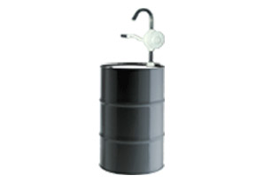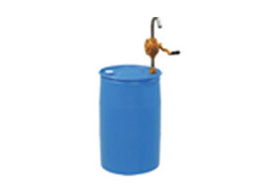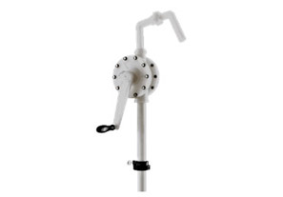

S.S. 304 Barrel Pumps S.S. 316 Barrel Pumps Teflon Rotary Hand Pump

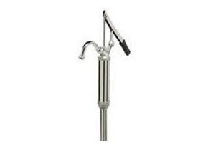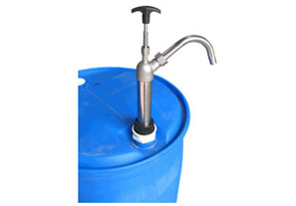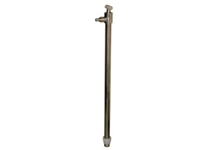

S.S. / Teflon Lever Piston Hand Pump S.S. 304 Piston Type Barrel Pumps S.S. 316 Piston Type Barrel Pumps

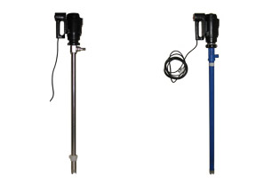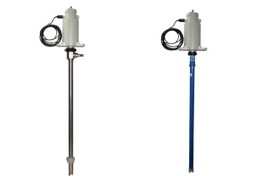

S.S. 316 Electric Drum Pumps S.S. 316 Flame Proof Electric Drum Pumps

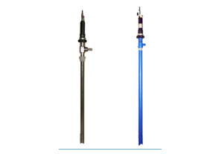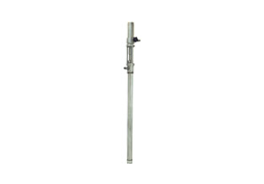

S.S. 316 Pneumatic (Air Operated) Drum Pumps S.S. 316 Air Operated Piston Pump

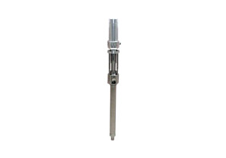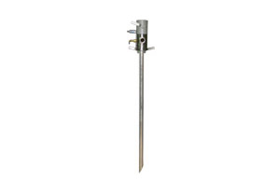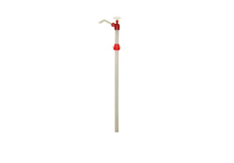

Wall Mounted Piston Pump Two Way Pump Nylon Chemical Piston Pump

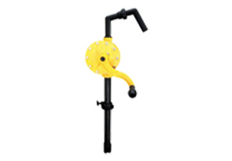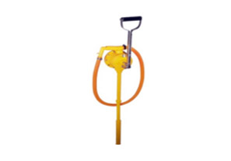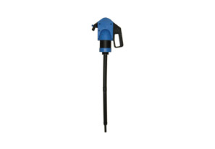

Polypropylene Rotary Barrel Pump High Quality Chemical Piston Pump Plastic Lever Pump

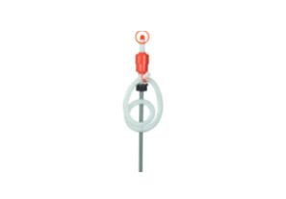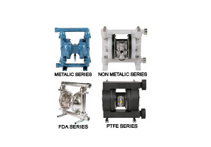

Polypropylene Rotary Barrel Pump Air Operated Double Diaphragm Pumps (AODD PUMPS)

FUEL AND OIL PUMPS

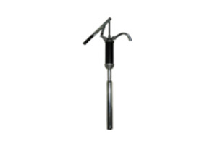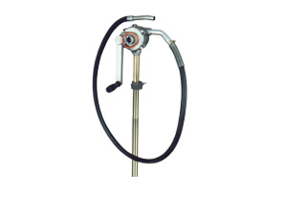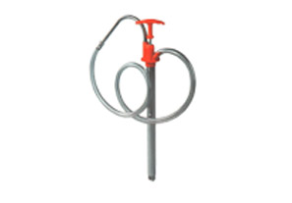

Barrel Pump - Lever Action Hi-Flow Rotary Barrel Pump Bucket Pump

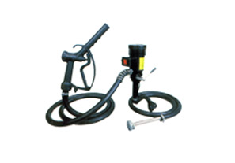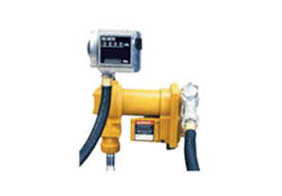

Electric Fuel & Oil Pump 12v DC Electric Fuel Transfer Pump

